SANITY CHECK EDGES 2023

ii= 31

dir : R:\McKenzieLab\DANEHippocampalResponse\NE2h2 (Named NE2m3)\Novel Environment\NE2h2\NE2h2-220310-101531

points = pointsLE

binX = -500:.5:500;

binY = binX;

distan = totalEdgDist(kp,1) ;

[n,~,~,ix] = histcn(points,binX,binY);

kpp = all(ix>0,2);

mean_dist = accumarray(ix,distan,[],@nanmean,nan);

%% Maybe add ix+1 in the accumarray if facing errors

figure

imagesc(mean_dist)

Contexts :

'homecage'

'CB'

'homecage'

'WB'

'homecage'

I = 1 (homecage)

Kp : 1:11959

Before: 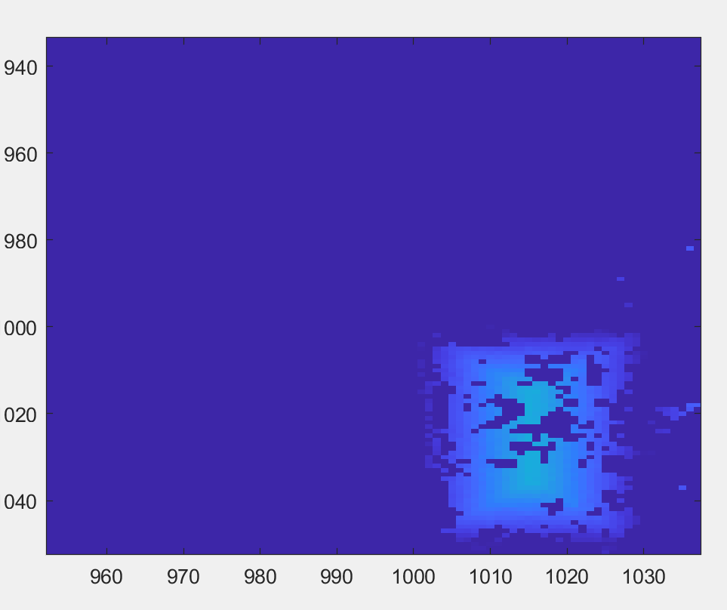

After:

Corrected context Transition kp = 35:11700;

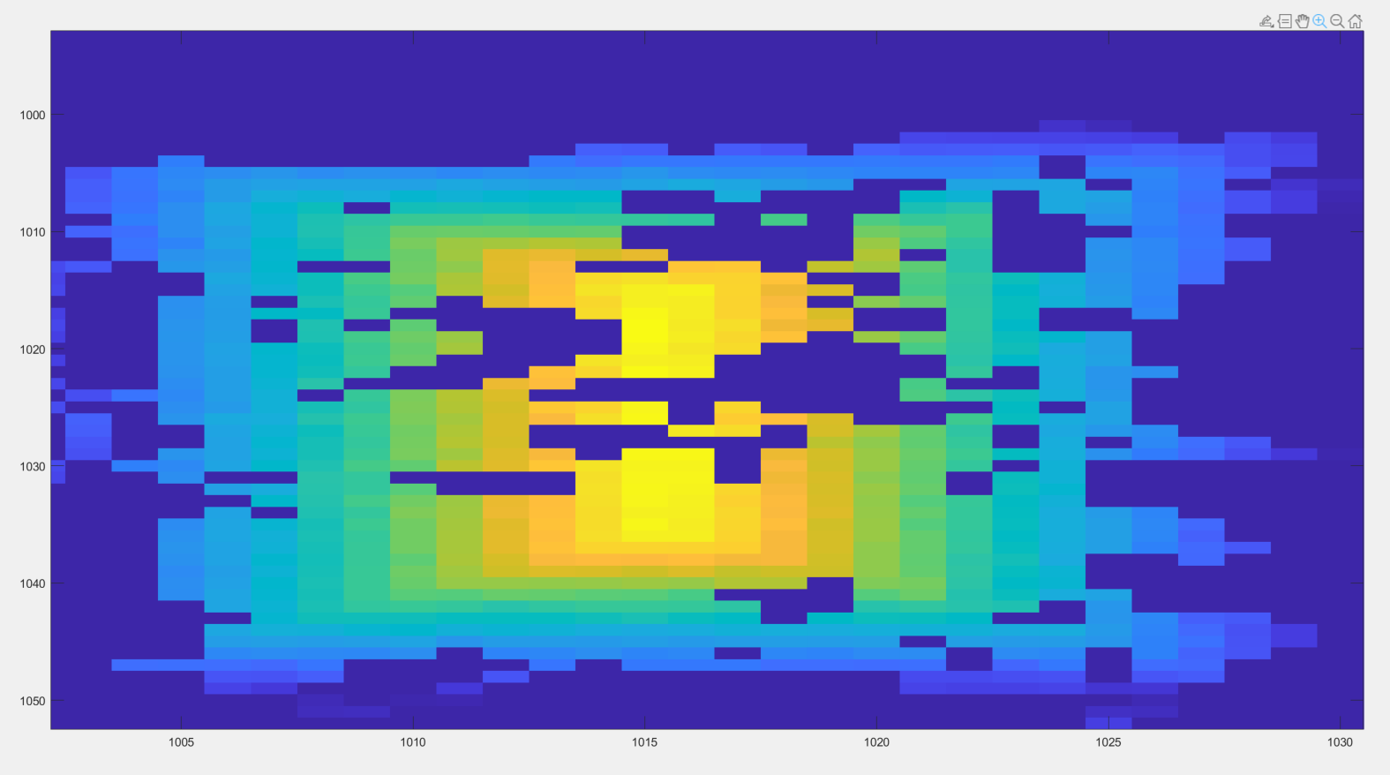

Before: (Check didn’t work?)

11960:25125

After:

11997: 23625

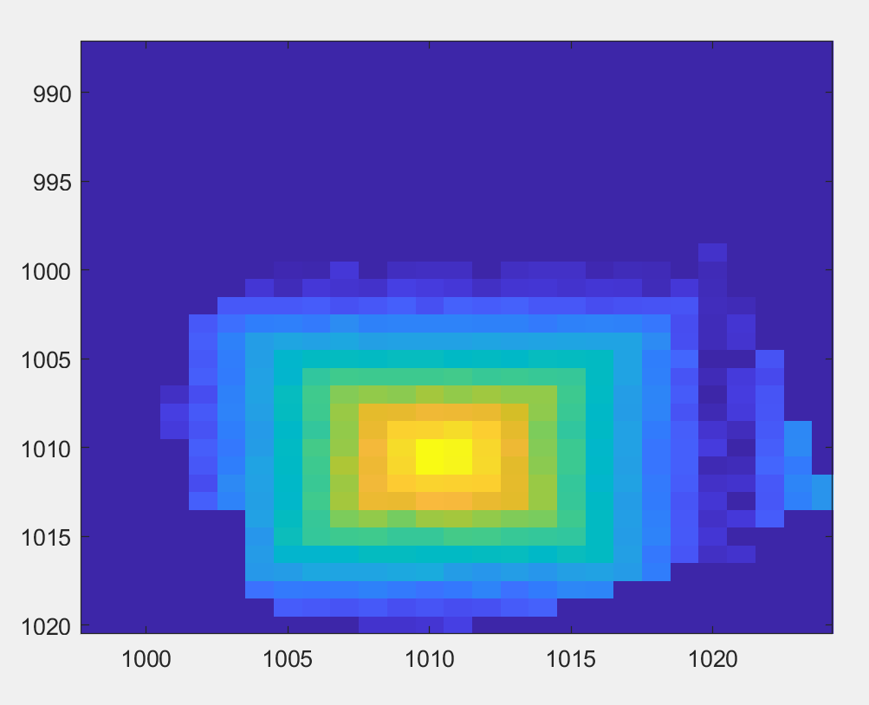

I = 3

Before: 25126: 45169

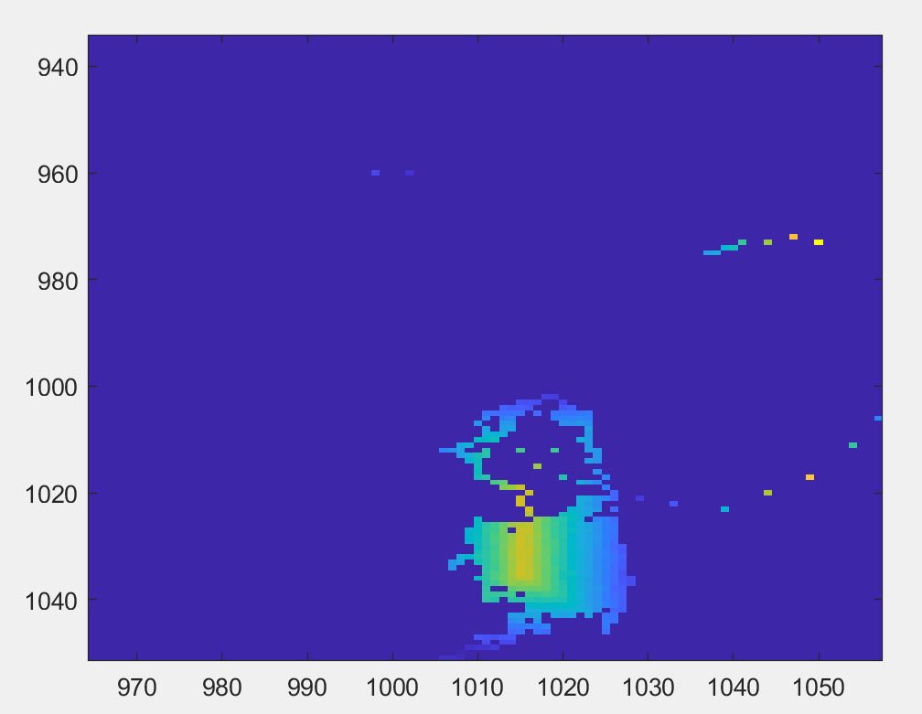

After: 25139: 45068

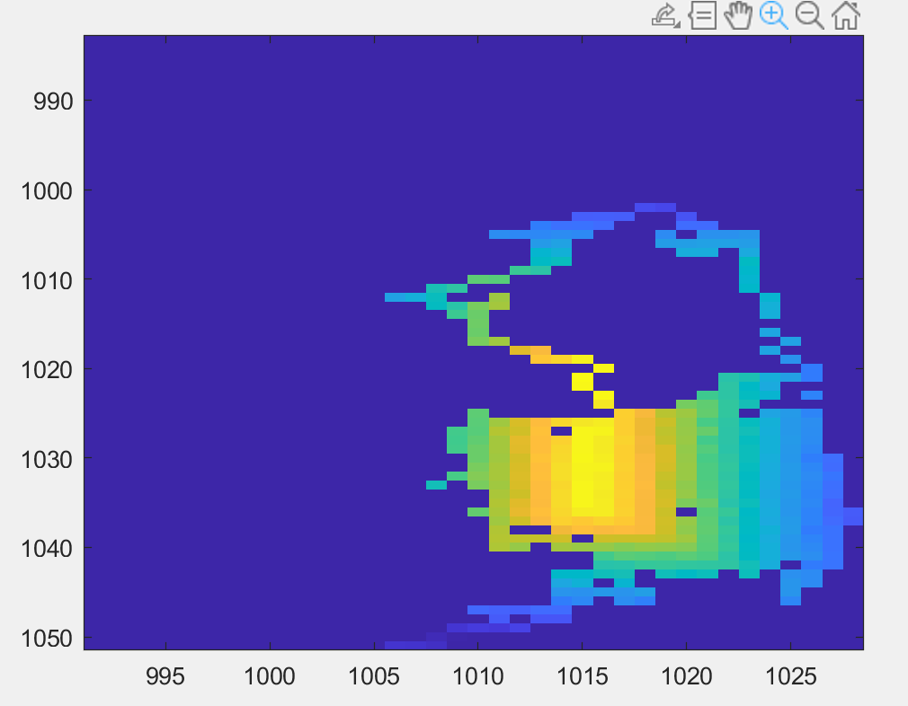

I = 4

Before: 45170:58189

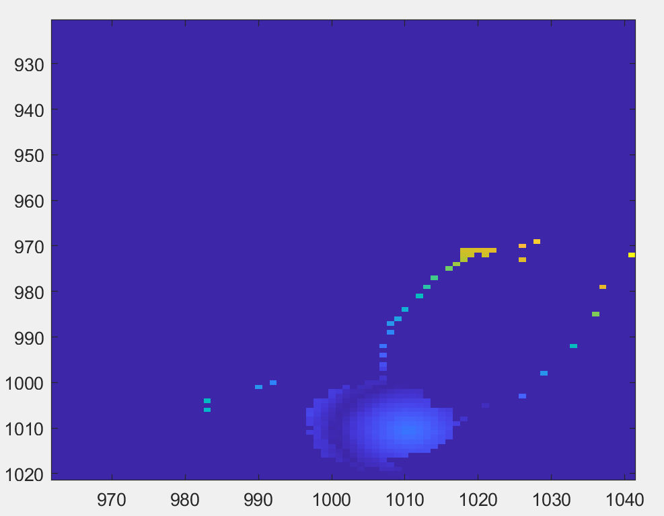

After: 45223:58141

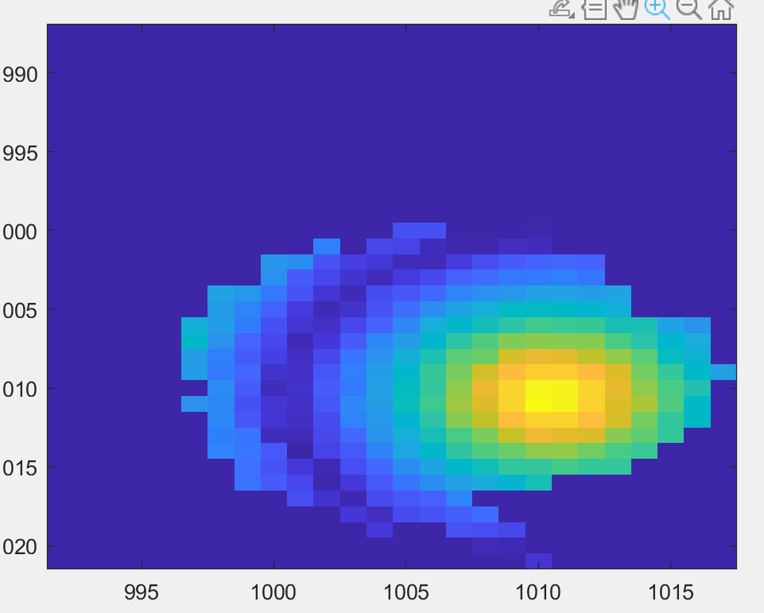

I = 5

